Food can be examined by many physical features and these features can be used to identify, as well as to see if the food products are genuine or not. A similar process was done on Raisins in Turkey, in which 7 physical features were extracted and based on those features, the raisins were classified into Bensi and Kecimen Raisins.

**Data Collection**

In this study, firstly, raisin sample images were obtained and were first converted to grayscale images and then converted to binary images. Then, using the imcomplement function (Similar to complement function) on binary images, black areas are converted to white and white areas to black. Later, the images were cleared of noise. In the next phase, various morphological feature inference operations were applied on the obtained images. During the classification phase, the classification of raisins was performed using LR (Logistic Regression), MLP (Multi-Layer Perceptron) and SVM machine learning techniques.

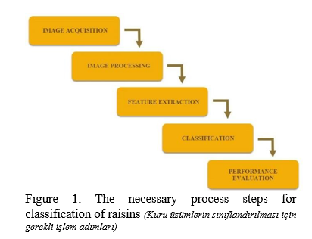

**Image Acquisition:** In order to get pictures of the raisins used in the study, a four-sided closed box with a camera and a light inside was set up. The box is closed off to keep external light from influencing the images and to reduce the formation of shadows on the samples. The bottom of the box is white, so the raisins will stand out clearly during image processing. Figure 2 below shows the 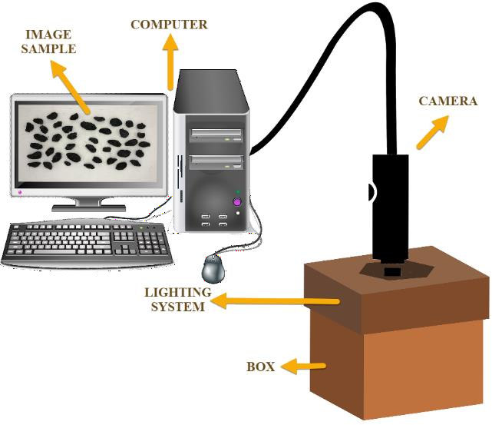system designed to take pictures of the raisins.

Figure 2. The computer vision system used to acquisition images *(Görüntü elde etmek için kullanılan sistem)*

A total of 900 images of raisins were obtained from both types of raisins used in the study, including 450 pieces. Sample images of the raisin varieties obtained are given in Figure 3.

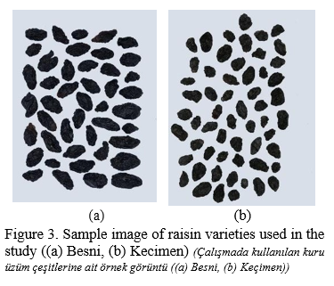

After this image processing is done to obtain the required results, which include using the Grayscale filter to make the image black and white and then converting them into binary images for better manipulations. After that the white areas of the image is converted to black and vice versa using the imcomplement function for better visibility.

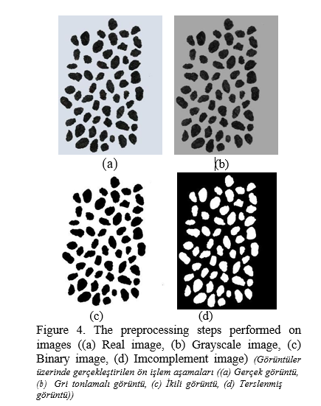

**Feature Extraction:** During the feature extraction phase, a number of feature inferences were performed for each of the raisins found on the images. Feature extraction process was carried out in terms of morphological features. A total of 7 morphological features were inferred for each one raisin grain which are included in data.

Area: Gives the number of pixels within the boundaries of the raisin grain.

Perimeter: It measures the environment by calculating the distance between the boundaries of the raisin grain and the pixels around it.

MajorAxisLength: Gives the length of the main axis, which is the longest line that can be drawn on the raisin grain.

MinorAxisLength: Gives the length of the small axis, which is the shortest line that can be drawn on the raisin grain.

Eccentricity: It gives a measure of the eccentricity of the ellipse, which has the same moments as raisins.

ConvexArea: Gives the number of pixels of the smallest convex shell of the region formed by the raisin grain.

Extent: Gives the ratio of the region formed by the raisin grain to the total pixels in the bounding box.